

DIVISION OF DATA SCIENCE AND CYBER SECURITY

SCHOOL OF COMPUTER SCIENCE AND TECHNOLOGY

A SKILL BASED EVALUATION REPORT

SUBMITTED BY
LEBI RAJA (URK24AI1005)

COURSE CODE 23DC2015

COURSE NAME
MACHINE LEARNING TECHNIQUES

April 2025

ONLINE CERTIFICATE
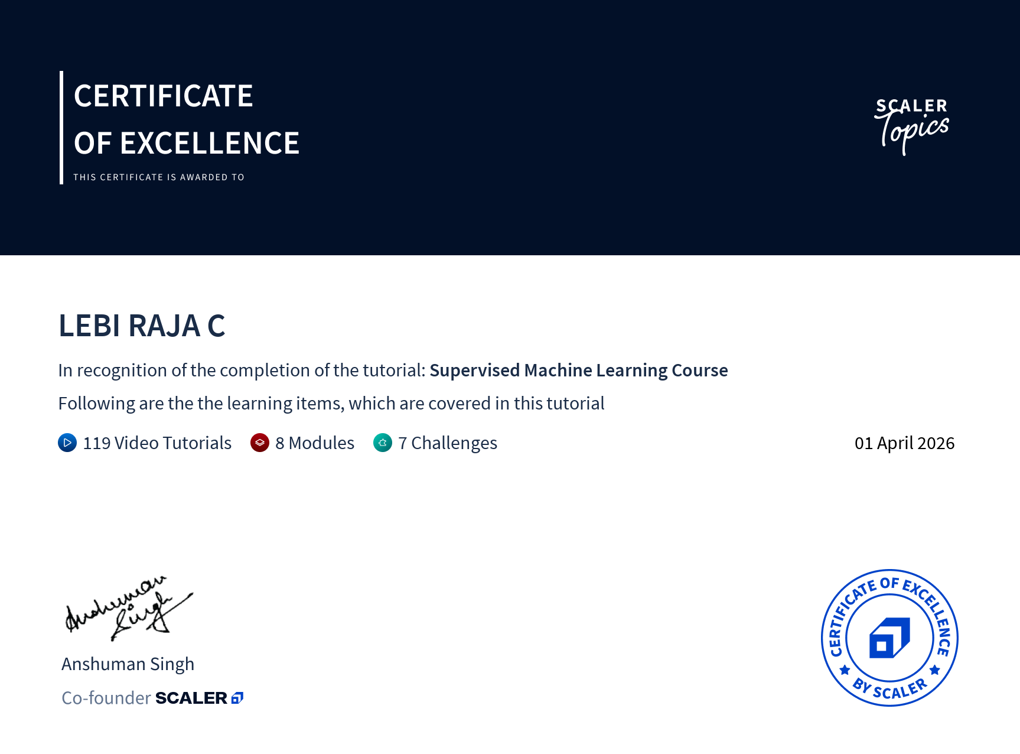

TITLE

RETINAL-AI

A REAL TIME APPLICATION REPORT

Submitted by
LEBI RAJA (URK24AI1005)
KP SHOHIL (URK24AI1001)



DIVISION OF DATA SCIENCE AND CYBER SECURITY

KARUNYA INSTITUTE OF TECHNOLOGY AND SCIENCES

(Declared as Deemed-to-be-under Sec-3 of the UGC Act, 1956) Karunya Nagar, Coimbatore - 641 114. INDIA

APRIL 2026.
ABSTRACT

- A brief summary of the project
- Objectives and scope of the project
- Algorithms used
- Result obtained
- Conclusion

<<write the content here>>
<< Font size-12>>
<<Font- Times new Roman>>
CHAPTER 1

INTRODUCTION

- Background information about the project
- Real-World Problem Description
- Problem statement and motivation
- Overview of the technologies used

<<write the content here>>
<< Font size-12>>
<<Font- Times new Roman>>
CHAPTER 2

LITERATURE REVIEW

- Review of relevant literature, frameworks, and libraries used in the project
- Comparison with similar projects or existing solutions

<<write the content here>>
<< Font size-12>>
<<Font- Times new Roman>>
CHAPTER 3
METHODOLOGY

- Explanation about your project
- Proposed/Used Machine Learning Algorithm(s)
- Workflow / Architecture Diagram Steps of Implementation:
- Data Preprocessing
- Feature Engineering
- Model Selection
- Training & Testing
- Evaluation Metrics

Novelty of your project Result discussion

<<write the content here>>
<< Font size-12>>
<<Font- Times new Roman>>
CHAPTER 4
IMPLEMENTATION

- Dataset used
- Detailed explanation of the implementation process
- Code snippets highlighting important functionalities

Result Analysis and Django-based Output
- Model Performance Metrics (Accuracy, Precision, Recall, F1 Score, etc.)
- Comparison with Benchmarks (if any)
- Web Interface with Django

  - Screenshots of the web app/dashboard
  - User Interaction / Input / Output mechanisms

<<write the content here>>
<< Font size-12>>
<<Font- Times new Roman>>
CHAPTER 5 TESTING AND VALIDATION

  - Description of the testing approach and methodologies used
  - Test cases and results
  - Validation of the system against the requirements

<<write the content here>>
<< Font size-12>>
<<Font- Times new Roman>>

CHAPTER 6
RESULTS AND DISCUSSION

  - Dataset used
  - Evaluation of the project's success in achieving its objectives
  - Discussion of any challenges faced during the development process
  - Result graph, confusion matrix
  - Comparison of your work with the existing work 🡪 show it with bar chart
  - Explain how your is better than the existing work

<<write the content here>>
<< Font size-12>>
<<Font- Times new Roman>>

CONCLUSION

  - Summary of the project
  - Achievements and limitations
  - Future enhancements and recommendations

<<write the content here>>
<< Font size-12>>
<<Font- Times new Roman>>
REFERENCES

  - List of all the references and resources used in the project

<<list the reference here with bullet>>
<< Font size-12>>
<<Font- Times new Roman>>
APPENDICES
  - Any additional information, diagrams, or code that are relevant but not included in the main report

<<write the content here>>
<< Font size-12>>
<<Font- Times new Roman>>
EVALUATION SHEET

Reg.No : URK24AI1005
Name: LEBI RAJA C
Course code: 23DC2015
Course Name: Machine Learning Techniques

S.No | Rubrics | Maximum Marks | Marks Obtained
1 | Online Certification Completion | 15
2 | Evaluation of Problem statement and Dataset with PowerBI data visualization | 5
3 | Methodology Implementation | 10
4 | Result Analysis and display using Django | 5
5 | Report | 5
Total |  | 40

Signature of the Faculty-in-charge

Signature of the Examiner1

